H.013842 Parcel 3-5 Photographs
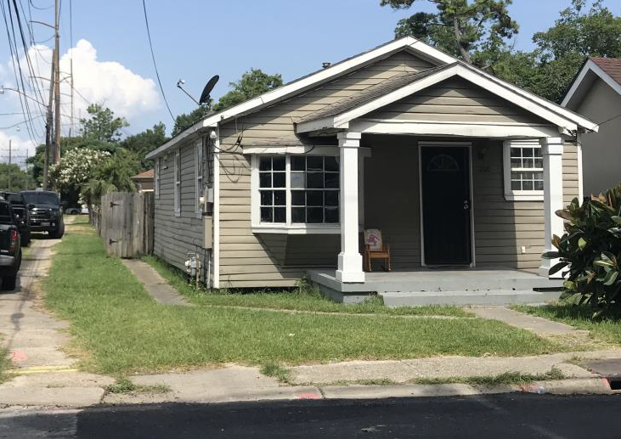
Photo of Front Elevation
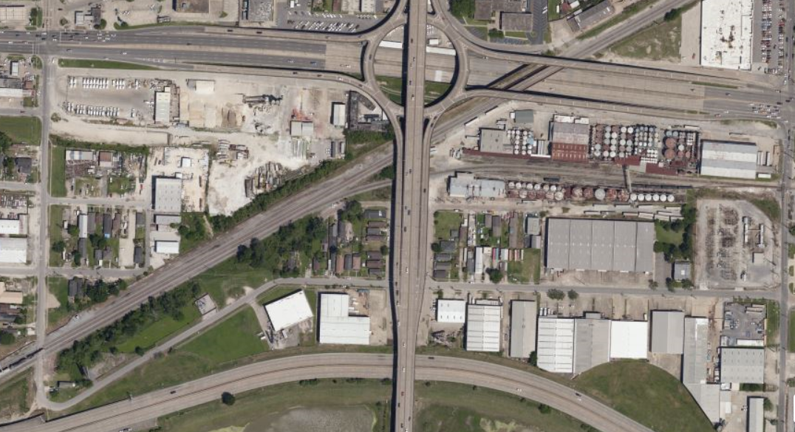
Earhart Expressway
Causeway Blvd.
Airline Highway
Area and location of the property.

